ERSS-1 spacecraft system mission analysis and design integration overview

Abstract
In April 2018, the Ministry of Innovation and Technology (MInT) formerly Ministry of Science and Technology (MOST) signed an agreement with the national development and reform commission of china to design and built the 1st Ethiopian earth observation satellite. The Ethiopian Remote Sensing Satellite (ETRSS-1) of 65kg was designed, developed and manufactured by DFH Satellite Company Ltd one of the subsidiaries of China Academy of Space Technology (CAST). The satellite was launched into space in 2019 from Taiyuan launch center with a mission of collecting an earth imagery data to address the Ethiopian climate changes.
Currently, the satellite is under operation by Ethiopian Space Science and Technology Institute (ESSTI) from sun synchronous orbit at an altitude of 628km and providing the necessary data to satisfy the application requirements of the fields such as agriculture monitoring, environmental and disaster monitoring, territory investigation, urban planning, mapping, forest and vegetation observation, etc. through ground control station facility located on Entoto. This study is aimed to introduce an overview of synthetic ETRSS-1 spacecraft system design, mission status, payload complement and its ground segment facility. Also, the major subsystems involved in the development of the satellite and its integration system will be discussed.

ETRSS-1 spacecraft system overview

The ETRSS-1 (Ethiopian Remote Sensing satellite) is Ethiopia’s first satellite launched on the December 2019 from Taiyuan launch center with a mission of collecting multispectral optical remote sensing data in the fields of agriculture, forestry, water conservancy, disaster prevention and mitigation in order to address the Ethiopian climate changes and weather-related phenomena [1]. The satellite was placed on sun-synchronous orbit at an altitude of 628.61km and collects imagery data at a ground sampling distance of 13.45meters within a revisit period of 4 days [2].
A 65kg of multi-spectral Ethiopian remote sensing satellite was developed and built at the DFH Satellite Company Ltd, CAST consisting of two distinct modules: the spacecraft base module (platform) and the payload (instrument module). The platform module of ETRSS-1 microsatellite comprehend the attitude and orbit control, onboard data handling, power supply, telemetry and telecommand, thermal control and structural subsystem to support the payload. The payload module includes a multi-spectral camera and data transmission system providing an imagery data.
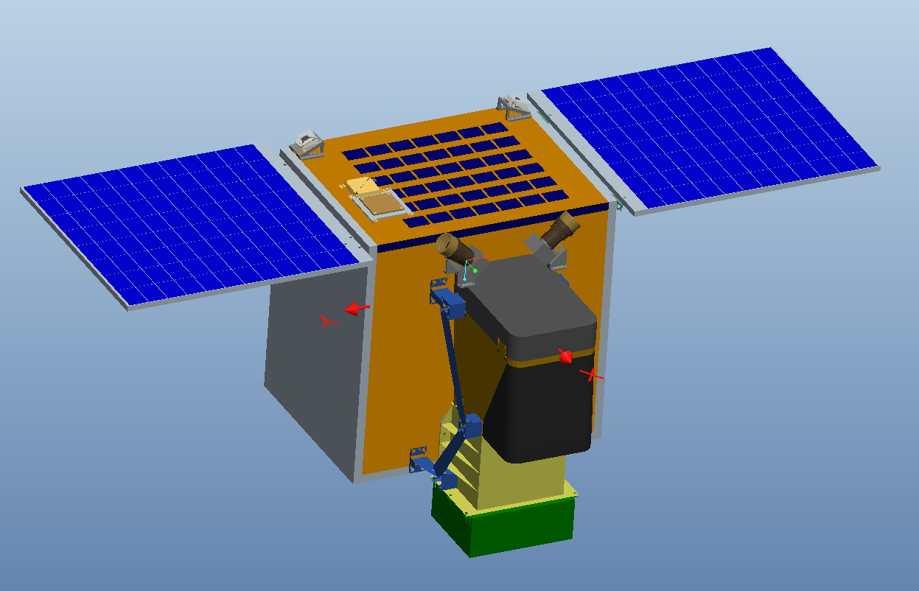
Figure 1: Illustration of ETRSS-1 configuration and layout (image credit: CAST)
General ETRSS-1 technical parameter
Table 1: ETRSS-1 technical parameter
Item | Technical parameters
Orbit | SSO  Altitude: 628km
Mass | 65kg
AOCS | 3-axis stabilized, zero-momentum control  Pointing Accuracy：0.1° (3σ, 3-axis in normal mode)  Pointing Stability：0.01°/s (3σ, 3-axis)  Attitude Determination Accuracy：0.05° (3σ, 3-axis)  Attitude Maneuver： ±35° (along roll axis)  Maneuver Capacity： 30°/70s
TT and C | USB + GPS
PSS | Output power of Solar Array more than 150W (EOL)  Li-ion Battery Capacity：20Ah
MSC | Type push-broom imaging  Spectral: B1/Blue：0.45μm ～ 0.52μm  B2/Green：0.52μm ～ 0.59μm  B3/Red：0.63μm ～ 0.69μm  B4/NIR：0.77μm ～ 0.89μm  GSD: ≤15m@628km  Swath: ≥60km@628km
DTS | Frequency Band: X band  Storage Capacity: 128Gbits  Downlink Data Rate: 100Mbps

Subsystem details

ETRSS-1 Launch and its mission status
Orbit design

ETRSS-1 Payload complements

ETRRS-1 Ground system

Conclusion

Reference

[1] Gunter’s space page, “ETRSS 1,” https://space.skyrocket.de/doc_sdat/etrss-1.htm, 2019.
[2] S. B. Tessema, “First Ethiopian Remote Sensing Satellite (ETRSS-1): Mission information and overview,” pp. 1–15, 2020, doi: https://doi.org/10.1002/essoar.10502532.1.

